TEST CASE 1 POI REPORT

*CVM Test Case 1 metric V87*

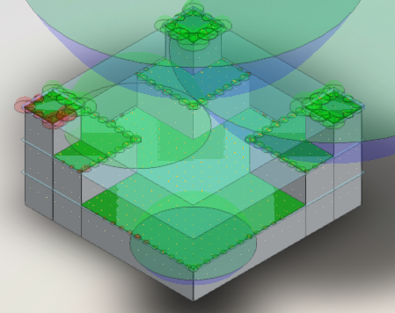

Table of Contents

Equations for Single-building Reductive 2

POI7 3

POI 11 4

## Equations for Single-building Reductive

## POI7

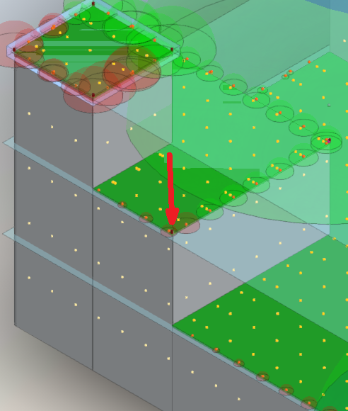

This point is a corner point. There appears to be a secondary point stacked upon the original point. The secondary sphere shows up as a generic point and contains no values:

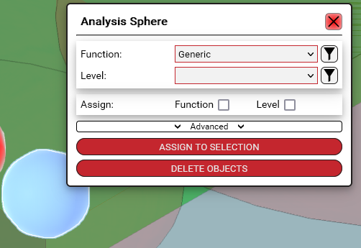

Re-running the analysis tool does not yield a result:

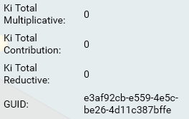



## POI 11

POI 11 has several POIs on top of each other. Discerning the proper point yeilds 0 for the reductive however another point nearby has the correct reductive values.

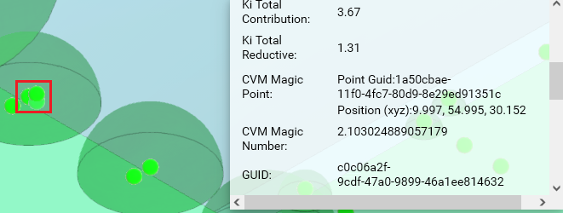



If the analyze form tool is utilized at 1000x1000 spacing the additional points are removed. The manually placed point that is remaining still yeilds 0 for its result on both multiplicative/reductive.

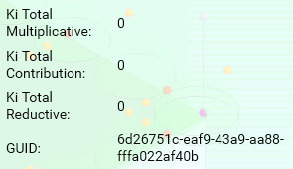

If the point is removed and a new point is created the x, y, z coordinates are significantly different than the original point:

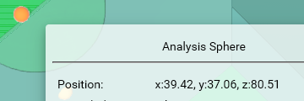

The new point also yeilds 0 for its reductive result despite requiring a reductive value. The coordinates for the POI should be:

